一、 Distinguish “冫” from “氵”

1. Categorize the characters in the box below by writing the characters based on the radicals “冫” and “氵”.

|  |
| --- |
| 河 冰 海 凉 冷 湖 沙 漠 冻 流 洗 溪 次 |

|  |  |
| --- | --- |
| **冫** | **氵** |
|  |  |

1. Look for characters with the radical 冫.   
   Then use the characters you to make a phrase/sentence.

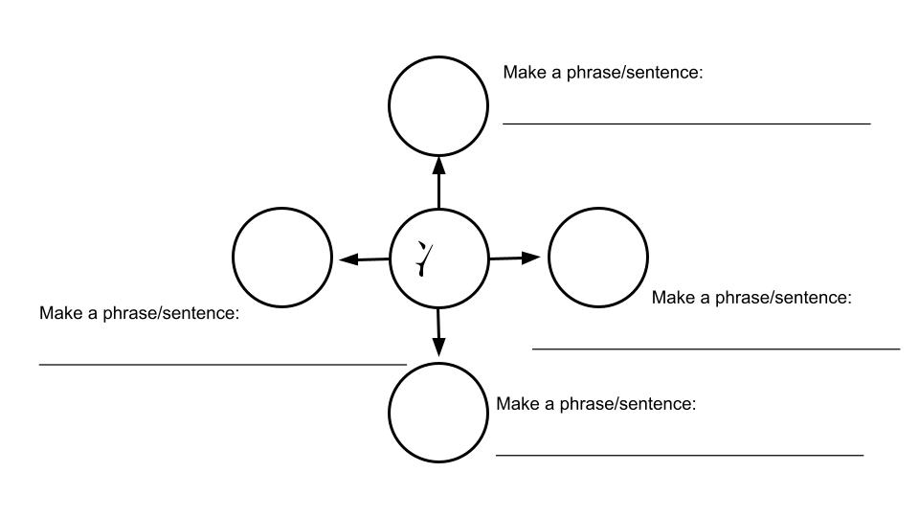

二、Distinguish “乐” lefrom “东”

1. Categorize the characters in the box below by writing the characters based on the radicals “乐” and “东”.

|  |
| --- |
| 陈 拣 炼 冻 练 冻 |

|  |  |
| --- | --- |
| **乐** | **东** |
|  |  |

三、The components of the character 赛

1. Use different colors to identify the components.

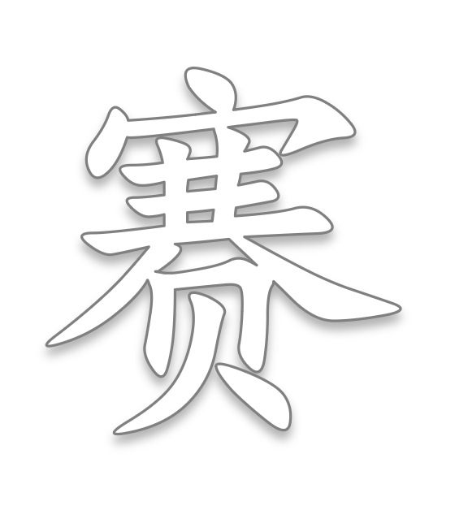

1. Use 赛 to make phrases and sentences. Use the pictures below as a reference.

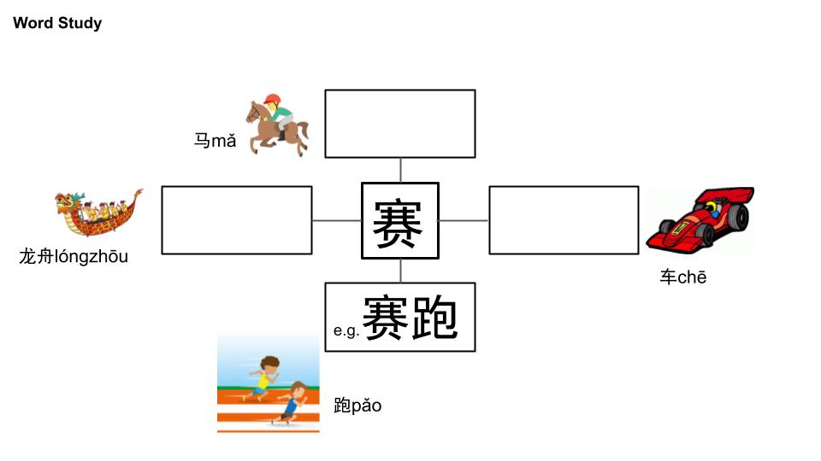

1. Fill in the blanks to complete sentences using the words provided.

|  |
| --- |
| 赛车 赛跑 赛龙舟 赛马 |

1. 每年端午节(duānwǔjié)，我最喜欢看_______________。
2. 爸爸开车开得很快，他非常喜欢_________。
3. 爷爷喜欢马，他经常看_________。
4. 弟弟跑得很快，所以他经常____________。

四、The components of the character 赢.

1. Use different colors to identify the components.

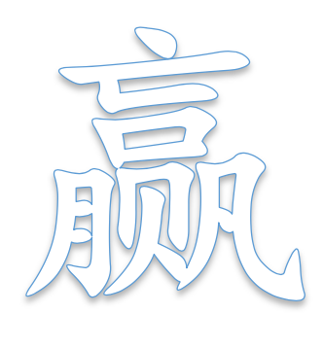

1. Write down the components and their meaning.

赢=( )+( )+( )+( )+( )

 赢

（ ）

（ ）

（ ）

（ ）

（ ）

五、Infer the meaning of unknow words by using the clues：

1. Please try to figure out the meaning of “电子琴”, by using the following clues

电子(dianzi)means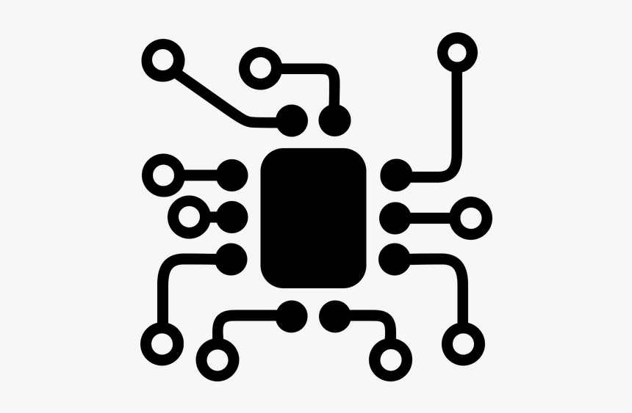, 琴(qín)means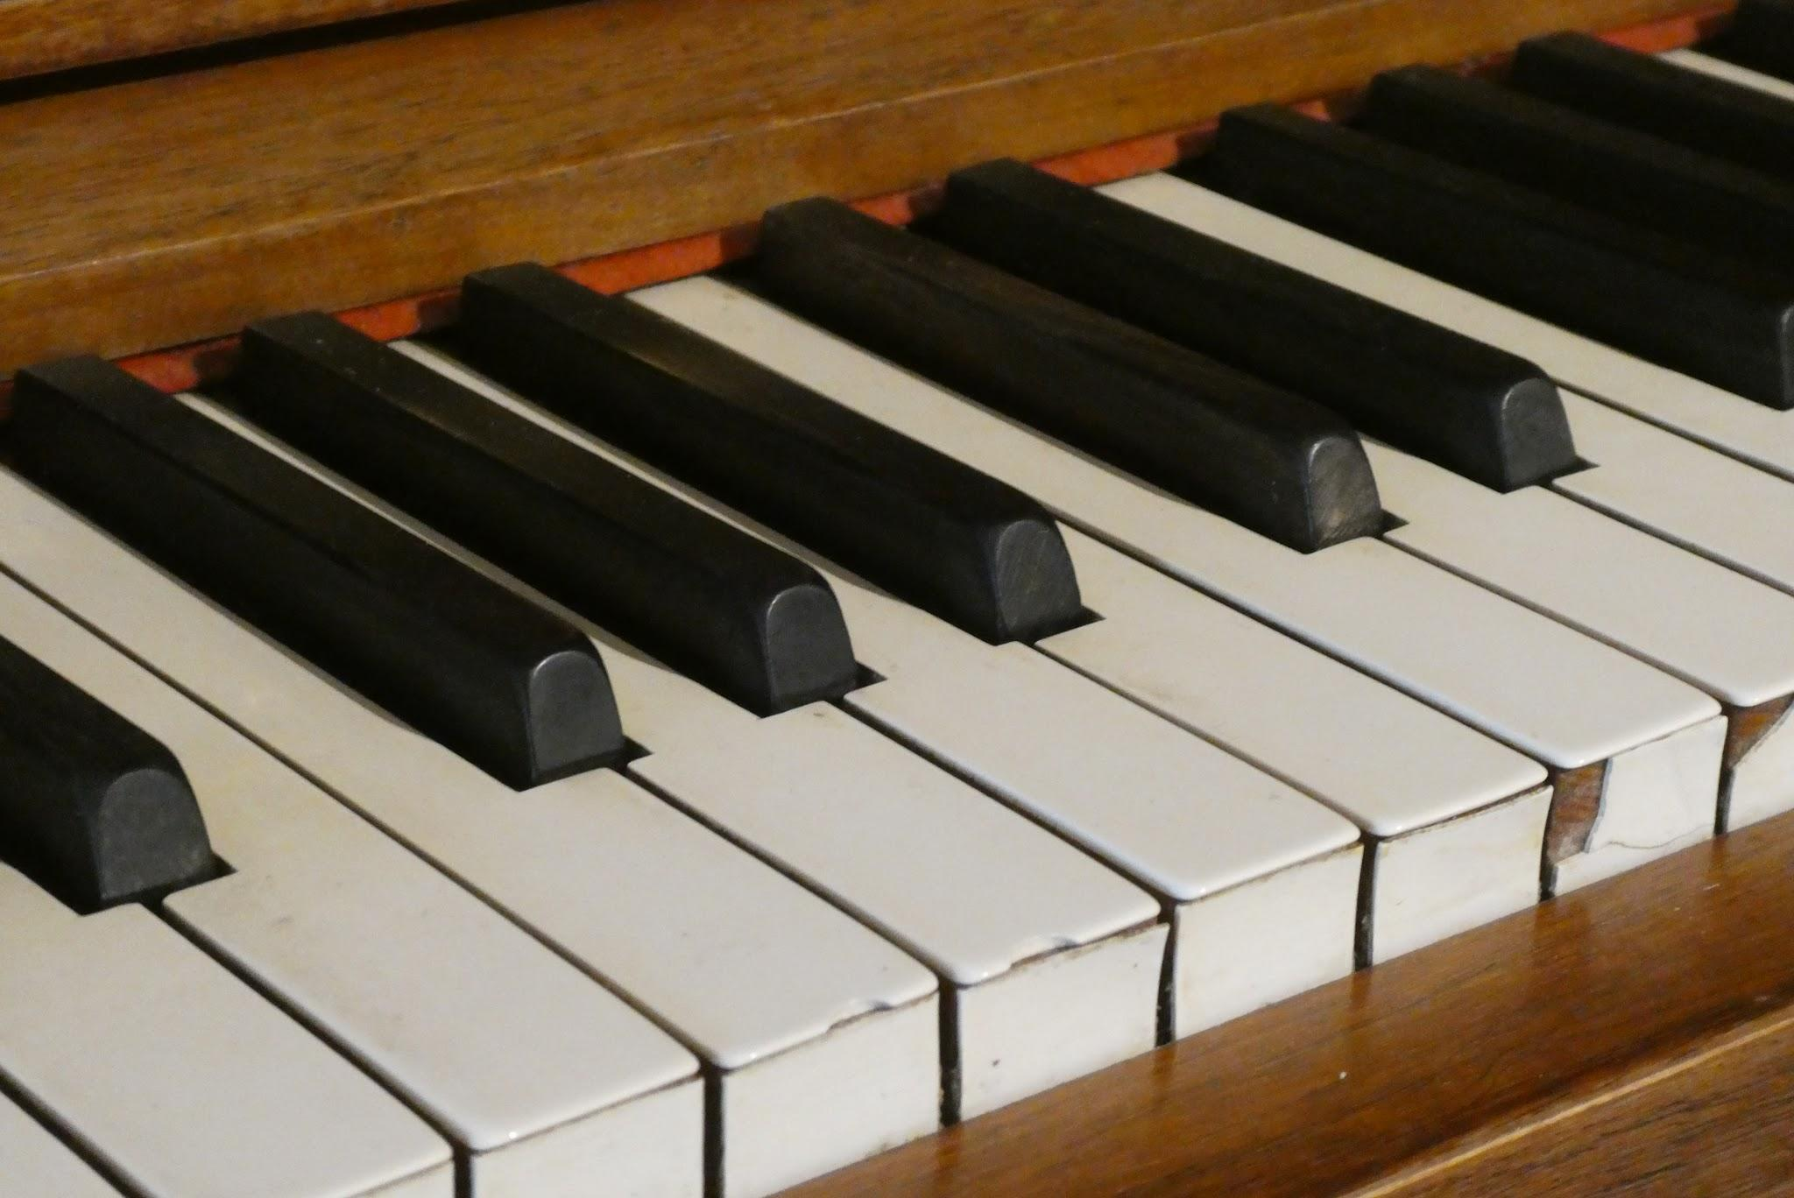

电子琴 means（ ）

1. Please try to figure out the meaning of “体校”, by using the following clues

体育(tǐyù)means 学校(xuéxiào)means

体校 means（ ）

1. Infer Use the known words to guess the meaning of the words below.

|  |  |  |
| --- | --- | --- |
|  | My guess | Write the correct meaning using an on-line dictionary. |
| 天 + 黑 = 天黑 |  |  |
| 排(pái, to line up) + 名  = 排名 |  |  |
| 有 + 名 = 有名 |  |  |
| 全(quán,whole) + 国  = 全国 |  |  |

Fill in the blanks with the words (天黑、排名、有名、全国) to complete the sentences.

1. 他是一位非常________的老师，________都知道他的名字。
2. 他现在的________是第三名，他的目标(mùbiāo, goal)是第一名。
3. ________了，我看不到路(lù,road)回家。

4. Review 员(yuán, person)：扩词练习

运动(yùndòng)+**员**

( )

店(diàn)+**员**

( )

服务(fúwù)+**员**

( )

演(yǎn)+**员**

( )

飞行(fēixíng)+**员**

( )

消防(xiāofáng)+**员**

( )

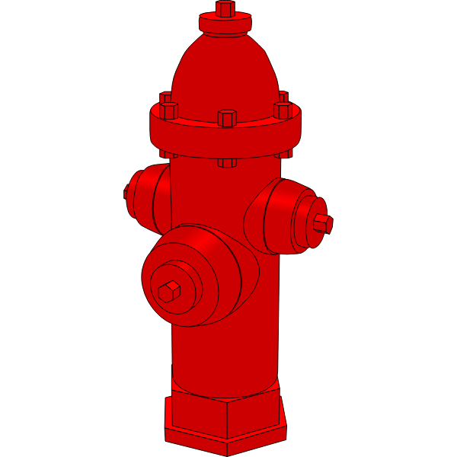

5. Fill in the blanks to complete the sentences using the words above.

1. 我的爸爸是一位________员，他经常去不同的国家旅行。
2. 弟弟是一位________员。他每天都去学校打篮球。
3. 这家面包店的________员非常亲切(qīnqiè,nice)，所以我很喜欢去。

6. Review 球(qiú, ball)：Building Block

write down the English meanings for the following words.

|  |  |  |  |  |  |  |  |  |  |  |  |  |  |  |  |  |  |  |  |  |  |  |  |  |  |  |  |  |  |  |  |  |  |  |  |
| --- | --- | --- | --- | --- | --- | --- | --- | --- | --- | --- | --- | --- | --- | --- | --- | --- | --- | --- | --- | --- | --- | --- | --- | --- | --- | --- | --- | --- | --- | --- | --- | --- | --- | --- | --- |
| |  |  | | --- | --- | | **球** |  | | 打**球** |  | | 看**球** |  | | 篮**球** |  | | 羽毛**球** |  | | 排**球** |  | | 网**球** |  | | 足**球** |  | | 美式足**球** |  | | |  |  | | --- | --- | | **球** |  | | **球**衣 |  | | **球**鞋 |  | | **球**帽 |  | | **球**场 |  | | **球**员 |  | | **球**队 |  | | **球**迷 |  | |